**LAB TASK # 3**

**With Diamond Problem**

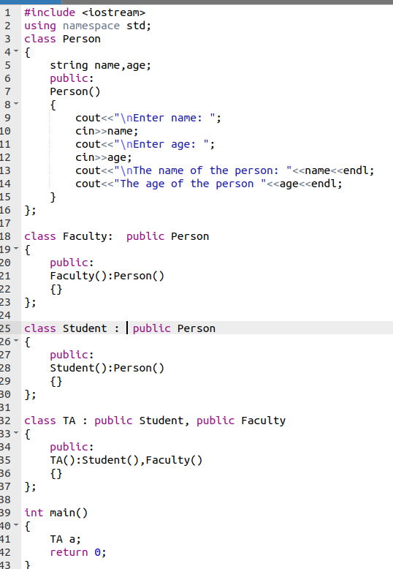

**OUTPUT**

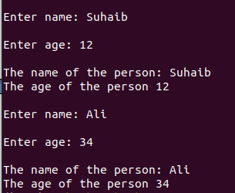

**Without Diamond Problem**

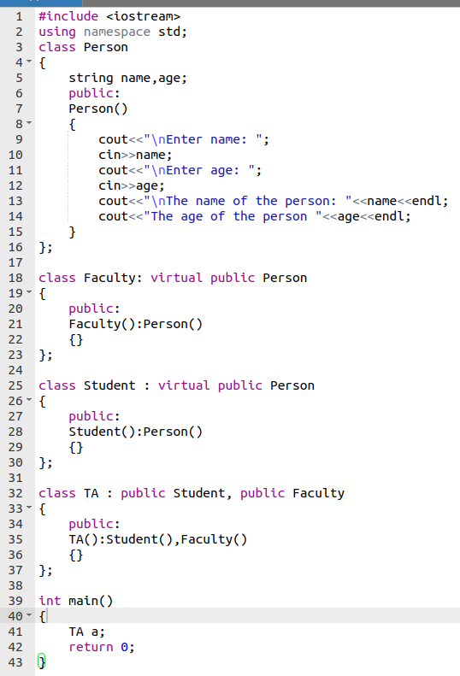

**OUTPUT**

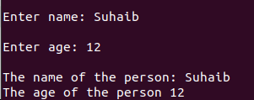

**Conclusion:**

In this lab I learned about the diamond problem in inheritance and how to avoid diamond problem using the **‘virtual’** keyword. Thus, if we are deriving two classes from the same class then we will use the virtual keyword and after that when we write a class that is derived from two class then we won’t get the diamond problem.